DataGridView

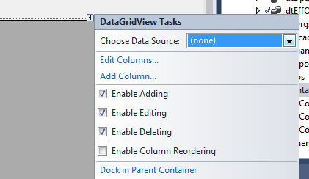

Choose Data Source

Add Project Data Source

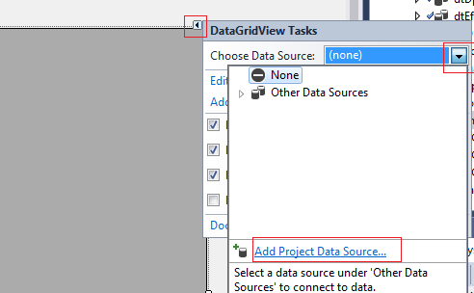

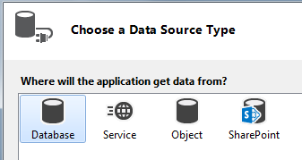

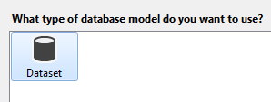

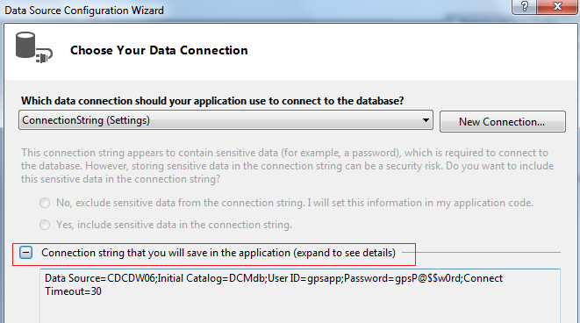

By default the one in app.config

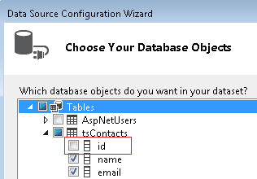

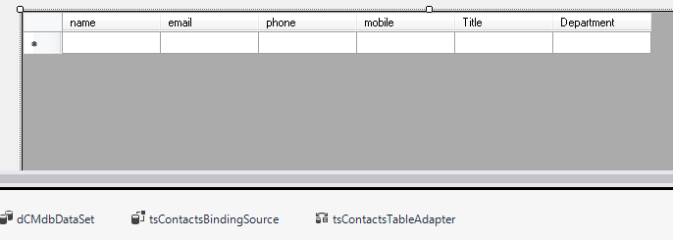

Update button

private void button2_Click(object sender, EventArgs e)

{

this.tsContactsTableAdapter.Update(this.dCMdbDataSet.tsContacts);

MessageBox.Show("Data Updated");

// reload data in memory

DataTable dt = Variables.GetDT("select id, name from tsContacts order by name");

Variables.lstContact.Clear();

foreach (DataRow dr in dt.Rows)

{

Variables.lstContacts.Add(new listado() { Value = System.Convert.ToInt32(dr[0].ToString()), Text = dr[1].ToString() }); ;

}

}

comando.CommandText = "select id, name from tsContacts order by name ";

dataAdapter.SelectCommand = comando;

DataTable dt7 = new DataTable();

dataAdapter.Fill(dt7);

foreach (DataRow dr in dt7.Rows)

{

string nombreContact = dr[1].ToString();

Variables.lstContacts.Add(new listado() { Value = System.Convert.ToInt32(dr[0].ToString()), Text = dr[1].ToString() }); ;

}

public static List<listado> lstContact = new List<listado>();

public class listado

{

public int Value { get; set; }

public string Text { get; set; }

public string Code { get; set; }

}